Differential Amplifier
Definition: A differential amplifier is an electronic circuit that amplifies the difference between two input voltages while rejecting or suppressing signals that are common to both inputs (common-mode signals). This property makes it highly suitable for noise cancellation and precise signal processing in analog systems.
Operating modes of differential amplifier
- Dual input balanced output
- Dual input unbalanced output
- Single input balanced output
- Single input unbalanced output
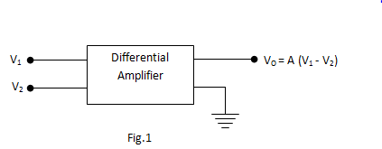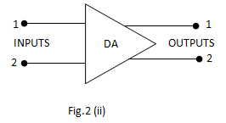
Block diagram of Differential Amplifier (DA) and it’s Symbol

- Differential Voltage Gain
The differential voltage gain is defined as:
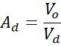
Where difference signal is the difference between the two signals
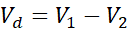
Thus,
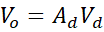
- Common-Mode Voltage Gain
The common-mode voltage gain is:
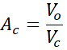
Where the common-mode signal is the average of the two input signals:
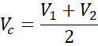
Thus,
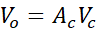
Total Output Voltage of a practical differential amplifier is:
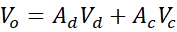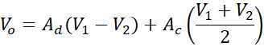
- Common Mode Rejection Ratio (CMRR)
CRR is defined as the ratio of differential gain to common-mode gain:
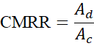
In decibels:
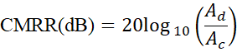
For an ideal amplifier:
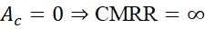
For a practical amplifier:
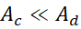
A differential amplifier amplifies the difference between two input signals while rejecting common-mode signals. It offers:
- High Common Mode Rejection Ratio (CMRR)
- High input impedance
- Good thermal stability
Hence, it is widely used in instrumentation systems and as the input stage of operational amplifiers

- BJT Differential Pair/Amplifier:
Circuit Diagram:

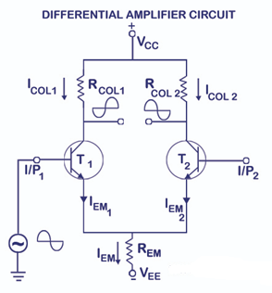

Operation of BJT Differential Amplifier (Input Applied to I/P1)
When an input signal I/P1 is applied to the base of transistor T1, the operation of the differential amplifier is as follows:

Operation of Transistor T1
- For a positive input at I/P1, transistor T1 conducts more current.
- Hence, the collector current of T1 increases, resulting in a larger voltage drop across the collector resistor .
- As a result, the collector voltage of T1 decreases (becomes less positive).
- When the input I/P1 is negative, transistor T1 conducts less (or turns OFF).
- Therefore, the collector current decreases, the voltage drop across becomes small, and the collector voltage of T1 increases (becomes more positive).
Thus, an inverted output appears at the collector of transistor T1 for the input applied at I/P1.
Effect on Transistor T2
- When T1 conducts more current, the total emitter current increases, since the emitter current is approximately equal to the collector current.
- This causes an increase in voltage drop across the emitter resistance .
- As a result, the emitter potential of both transistors T1 and T2 increases.
- An increase in the emitter voltage of T2 is equivalent to making its base voltage relatively negative.
- This reduces the conduction of T2, thereby decreasing its collector current.
- With reduced collector current, the voltage drop across of T2 decreases, and the collector voltage of T2 increases (becomes more positive).
Hence, a non-inverted output appears at the collector of transistor T2 for an input applied at the base of T1.

Differential Operation
- The output of the differential amplifier may be taken differentially between the collectors of T1 and T2, which gives an amplified difference of the input signals.
- If T1 and T2 are identical and equal input voltages are applied, then the emitter currents are equal:
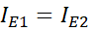
The total emitter current is:
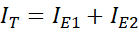
Hence, each emitter current is:
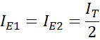
The total emitter current is given by:
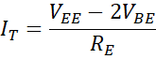
Since 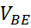is almost constant, the emitter current remains nearly constant and is independent of transistor .
Since:
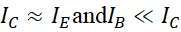
If is large, we may write simply:
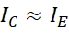
- Small Signal Operation:
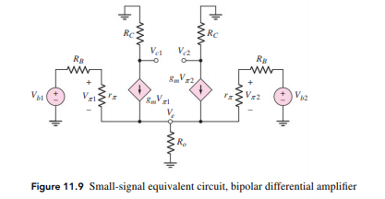
Differential Gain 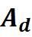
Consider a BJT differential amplifier with:
- Collector resistance
- Emitter resistance (or tail resistance 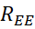)
- Small-signal emitter resistance 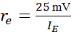
For differential excitation 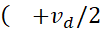and 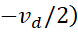, the common emitter node is at AC ground.
Small-signal collector current:
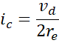
Output voltage:
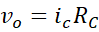
Hence differential gain:
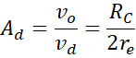
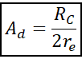
Common-Mode Gain 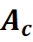
For common-mode excitation:
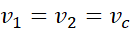
The emitter node is not at AC ground due to finite tail resistance .
Effective emitter resistance seen by each transistor:
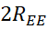
Collector current:
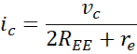
Output voltage:
Thus common-mode gain:
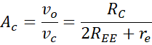
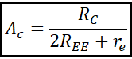
Expression for CMRR
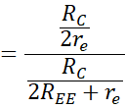
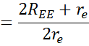
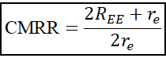
Approximation
If:
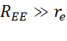
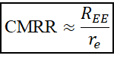
MOSFET Differential Pair/Amplifier:

Circuit Diagram:
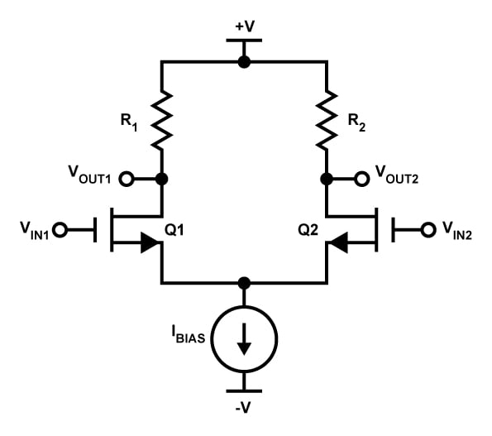
Operation:
The MOSFET differential amplifier consists of two identical MOSFETs Q1 and Q2. Their sources are connected together and biased using a constant current source. The drains are connected to the positive supply through drain resistors . Input signals and are applied to the gates.
- When a positive input signal is applied to the gate of MOSFET Q1, its drain current increases.
- Due to the constant tail current, the drain current of Q2 decreases correspondingly.
- The increased current in Q1produces a larger voltage drop across its drain resistor, causing its drain voltage to decrease.
- Simultaneously, the reduced current in Q2causes its drain voltage to increase.
Thus:
- Output at drain of Q1is inverted
- Output at drain of Q2 is non-inverted
- When equal input voltages are applied to both gates, the drain currents are equal and the output voltage ideally becomes zero.
MOS differential amplifiers offer high input impedance and are widely used in integrated circuits and operational amplifiers.
- Small Signal Operation:
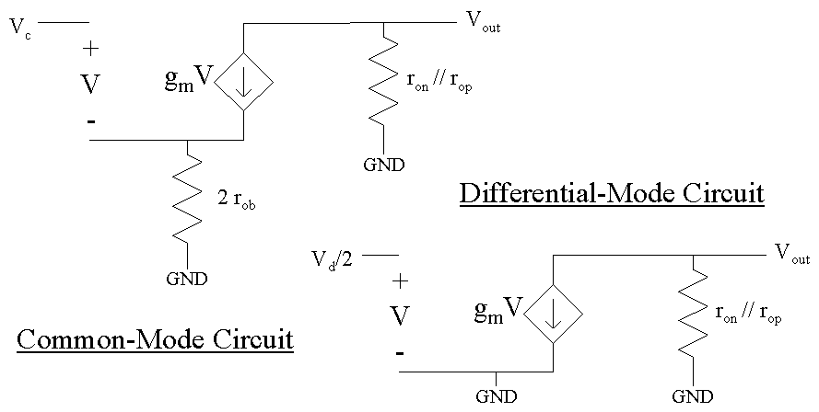

The Common Mode Rejection Ratio (CMRR) is defined as the ratio of differential gain to common-mode gain:
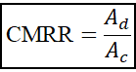
Differential Gain
Consider a MOS differential amplifier with:
- Drain resistance
- Transconductance
- Tail current source resistance 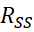
For differential excitation and , the source node is at AC ground.
Small-signal drain current:
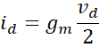
Output voltage:
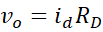
Hence differential gain:
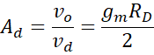
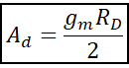
Common-Mode Gain
For common-mode input:
The source node is not at AC ground due to finite tail resistance .
Source voltage:
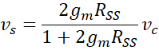
Effective gate-to-source voltage:
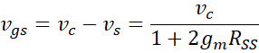
Drain current:
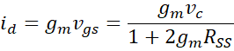
Output voltage:
Thus common-mode gain:
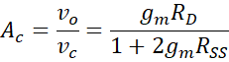
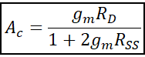
Expression for CMRR
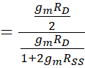
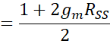
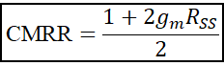
Approximation (High Tail Resistance)If:
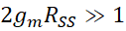
Then:

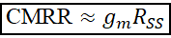

Ideal and Non-Ideal Characteristics of a Differential Amplifier
Parameter | Symbol | Ideal Differential Amplifier | Non-Ideal (Practical) Differential Amplifier
Differential Gain |  | 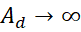 | is high but finite
Common-Mode Gain |  | 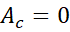 | 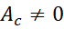(small)
Common-Mode Rejection Ratio | CMRR 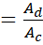 | 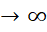 | Large but finite
Input Resistance |  | 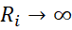 | is finite
Output Resistance |  | 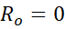 | 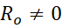
Transistor Matching | 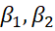, 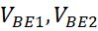 | 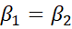, 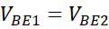 | 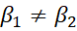, 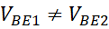
Input Offset Voltage | 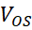 | 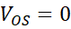 | 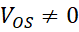(small)
Bandwidth | BW | Infinite | Limited
Noise |  | 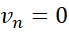 | 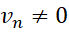
Total Harmonic Distortion | THD | THD = 0 | THD 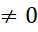
Temperature Sensitivity | 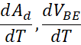 | Zero | Non-zero

